GBA 6220

Final Group Project

Group 8

**Business Description**

Mega Mart is a locally owned grocery store that sells produce and packaged products. Products are sourced from various vendors. The data set extracts all food products from the Mega Mart grocery department. Some of the key information from this dataset are department, category, subcategory, product name, brand, and retail price.

**Entities**

|  |  |
| --- | --- |
| **Entity** | **Description** |
| **CUSTOMER** | Contains customer information and a binary attribute to indicate whether a customer is a member or not. |
| **LOYALTY_MEMBER** | Stores loyalty member’s ID, total purchases, and points earned. |
| **INVOICE** | Invoice for customer purchases. |
| **PAYMENT** | Payment transaction for customer purchases. |
| **PRODUCT** | Product list with unique ID, price, brand, name, and quantity in stock. |
| **DEPARTMENT** | Department which the product belongs to. |
| **VENDOR** | Vendor supplying the product. |
| **VENDOR_PAYMENT** | Payment transaction for products purchased by the store from the vendor. |
| **EMPLOYEE** | Contains employee information and job code. |
| **JOB** | Job ID and job description. |

**Purpose**

1. To create a data entry management database for the products, that agree with the company's business rules, and keep track of inventory.
2. monitoring stockouts or overstock situations.
3. Analyzing sales trends to identify which products are performing well and which ones may need to be discounted or removed from the shelves.
4. Developing pricing strategies based on sales data and market trends.
5. Collaborating with vendors to negotiate pricing and payment terms.
6. Overall, the goal of the grocery department within a data warehouse project would be to leverage data to make informed decisions that improve the profitability and efficiency of the grocery business.

**Business Rule**

1. Grocery store only provides in-store shopping
2. Grocery store only sells food/perishable items
3. A customer must have a unique identifier such as an account number/customer ID
   1. If a customer doesn't have an account they are checked out as a guest with a default customer ID
4. All products have unique identifiers such as SKUs
5. All purchase transactions must include payments
6. Refunds are accepted in some cases (e.g. expired items) but do not go back into inventory.
7. When a customer makes a purchase, the inventory level is updated.
8. A product can only be supplied by one vendor, but a vendor can supply multiple products.

**Data Warehouse Rules**

1. Data quality: Ensure accuracy, completeness, and up-to-date data.​
2. Data security: Protect data from unauthorized access, disclosure, and modification.​
3. Data governance: Establish clear policies and procedures for data ownership, stewardship, and usage.​
4. Data integration: Integrate data from different sources into a unified view.​
5. Business Rules: Define and document rules for data validation, transformation, and aggregation.​
6. Performance: Optimize the data warehouse for efficient performance and high availability.​
7. Compliance: Comply with relevant regulations and standards, such as data privacy laws.​

**ER Diagram- Data Model**

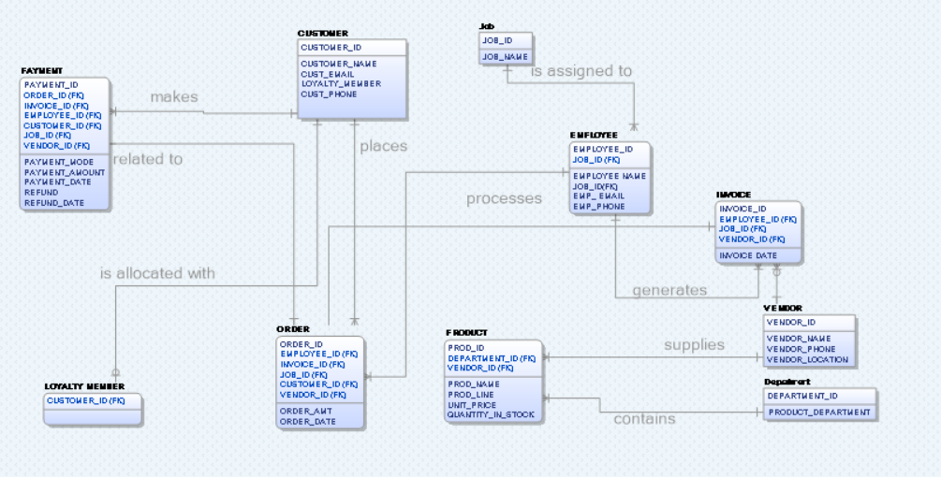

**ER Diagram- Data Warehouse**

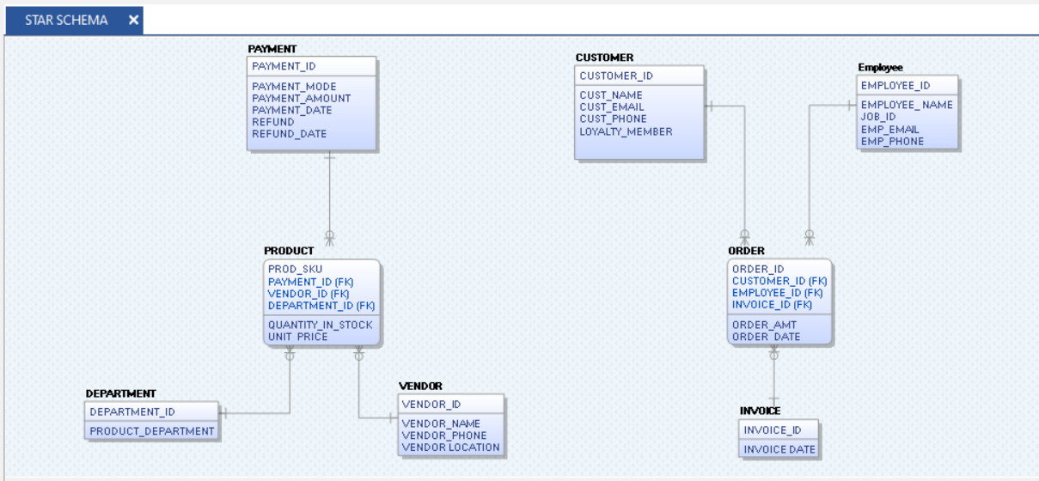

**Loading data in SSMS using SQL integration Services**

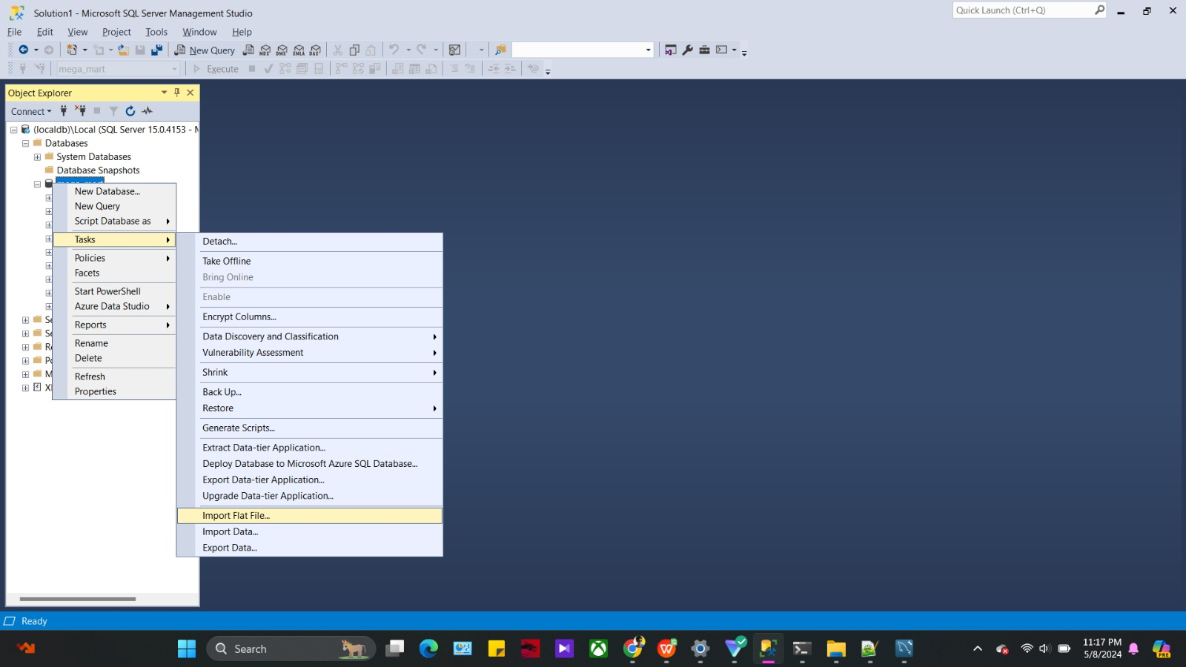

**Creating employee table-**

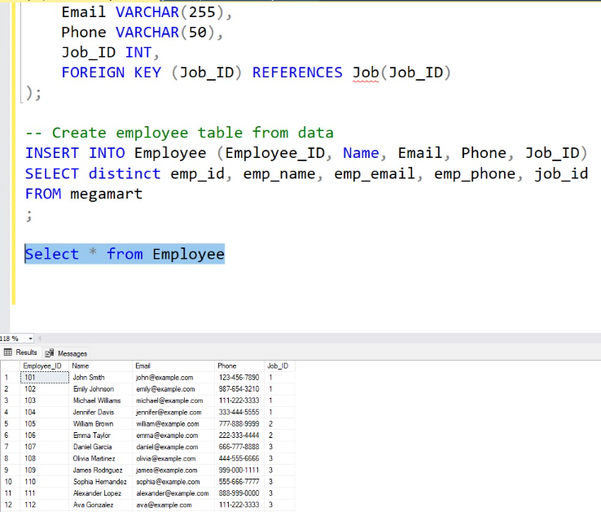

**Creating vendor table-**

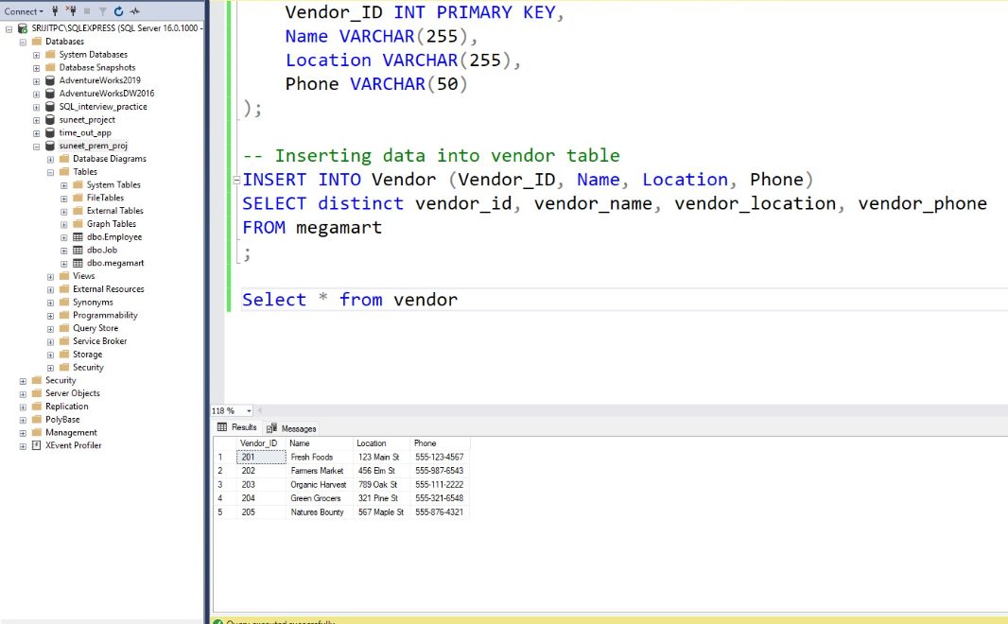

Creating Product table –

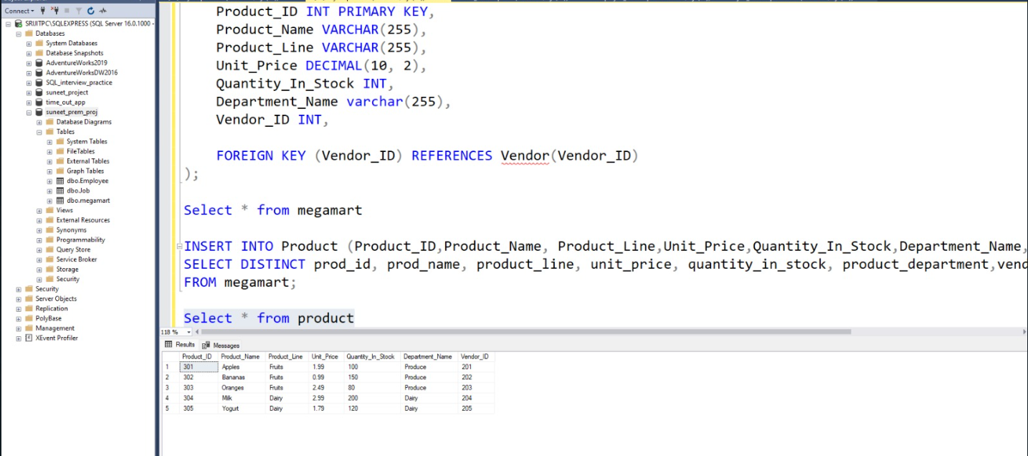

**Creating customer table-**

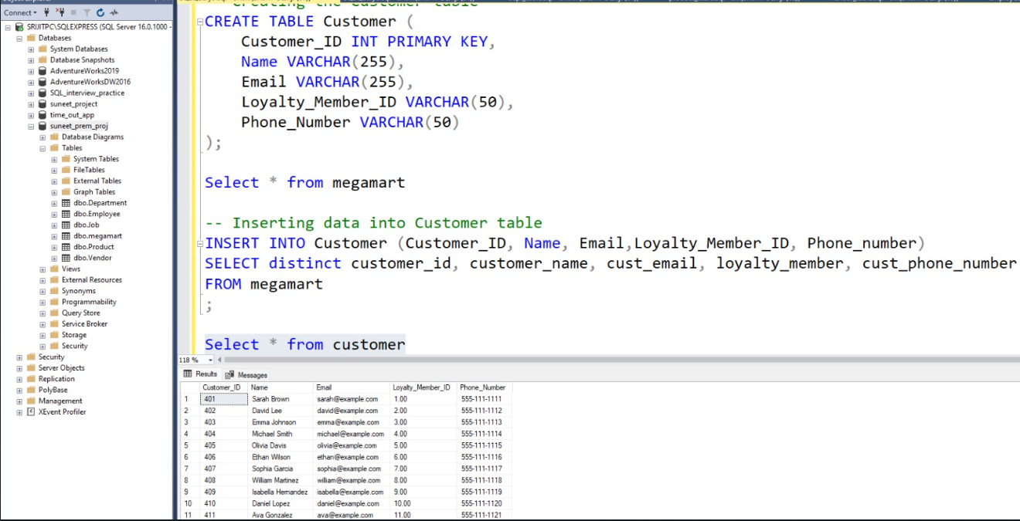

**Creating Invoice table-**

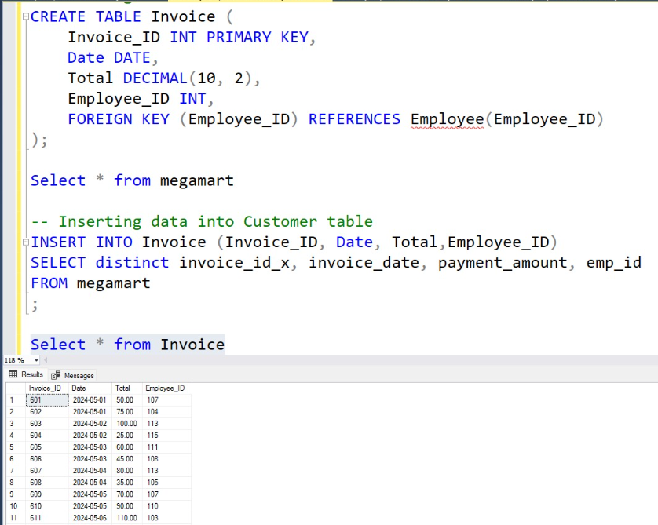

**Creating Payment table-**

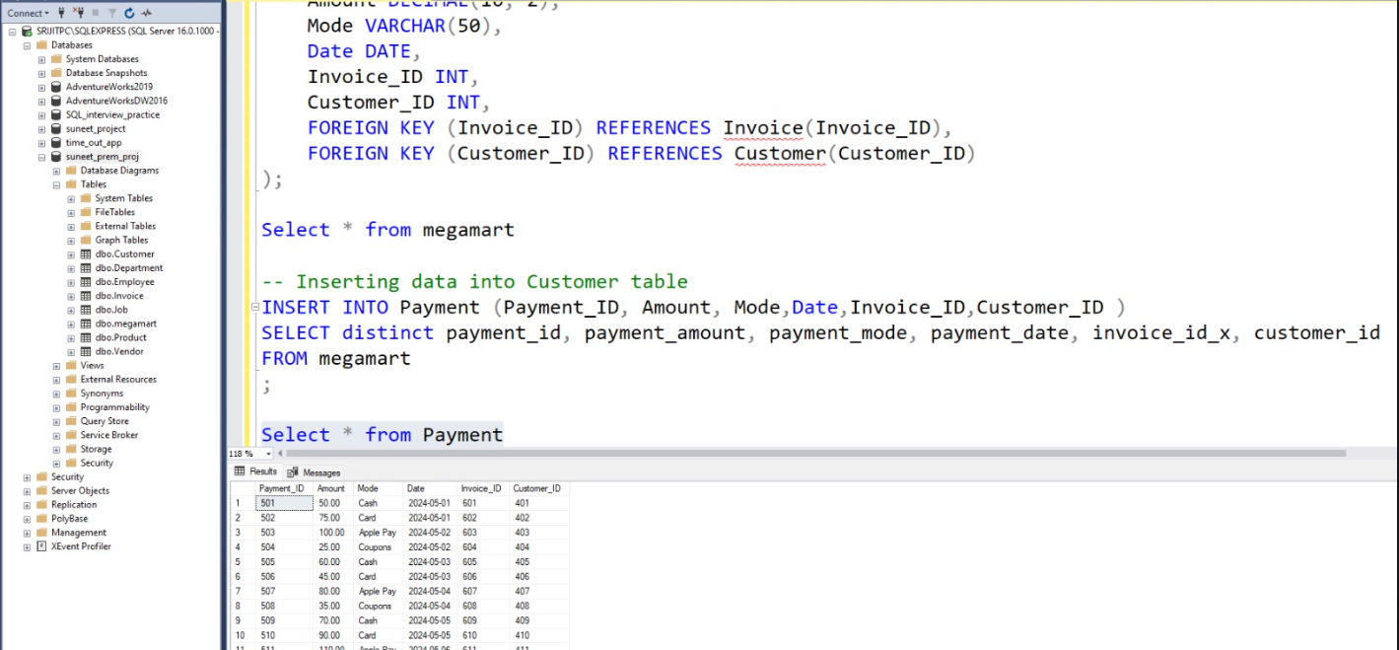

**Inserting data in order table-**

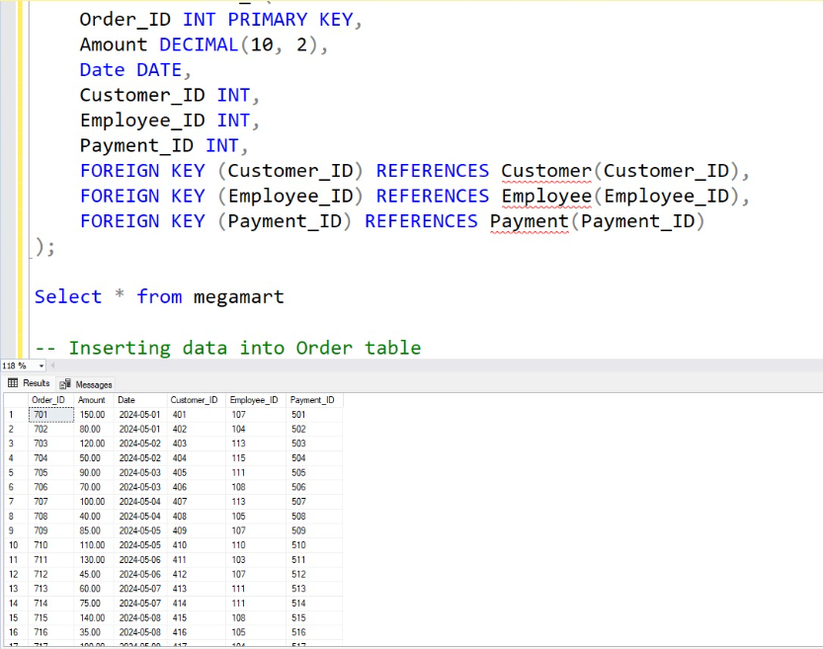

**How to calculate the sum in SSIS**

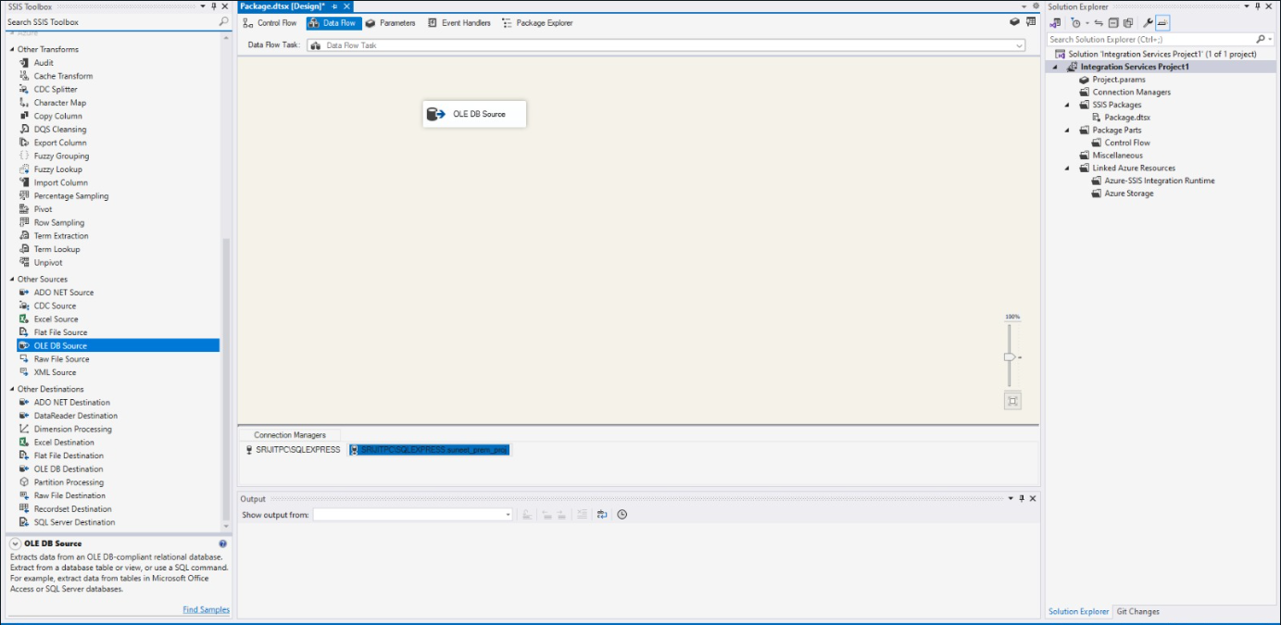

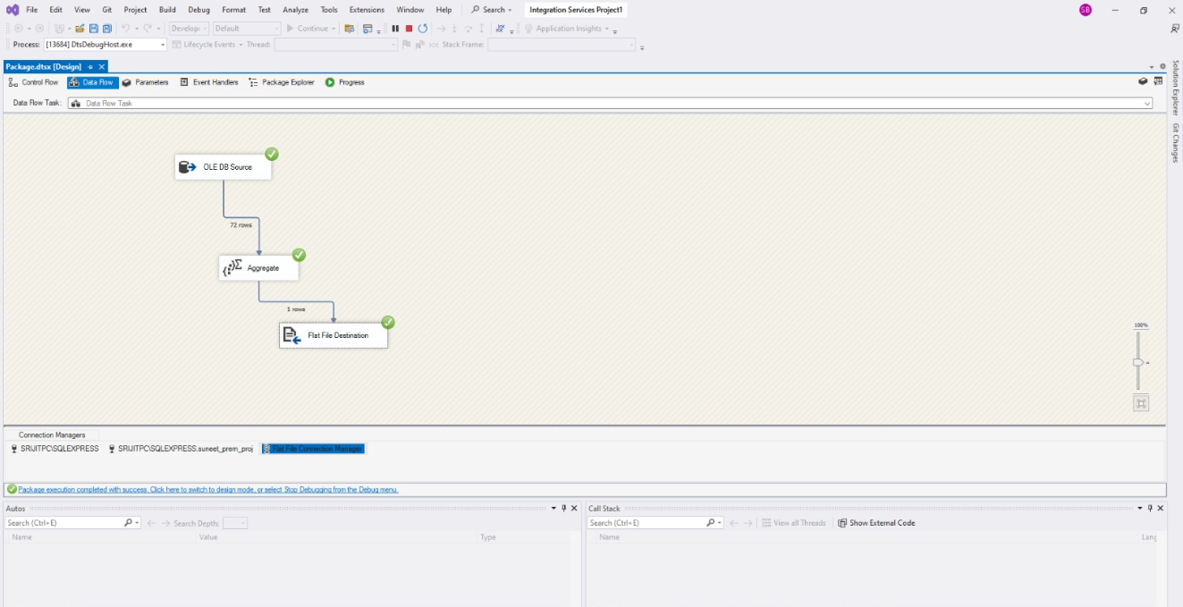

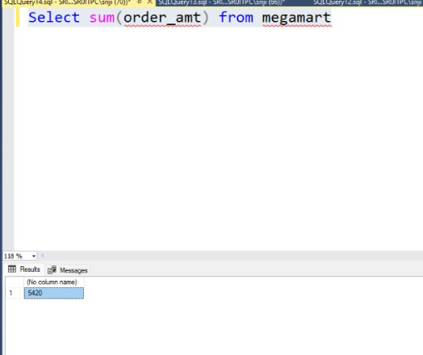

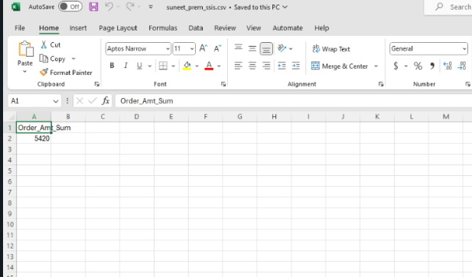

**Merging two table through SSIS**

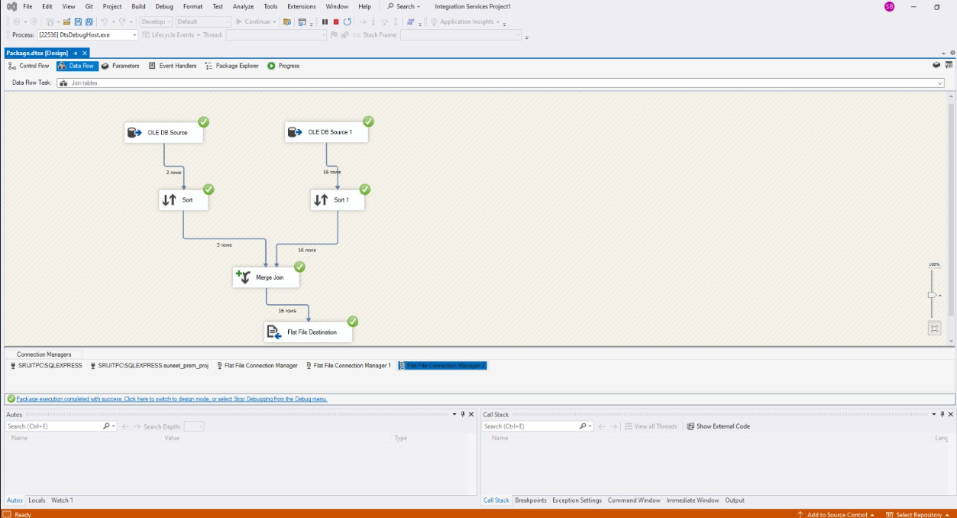

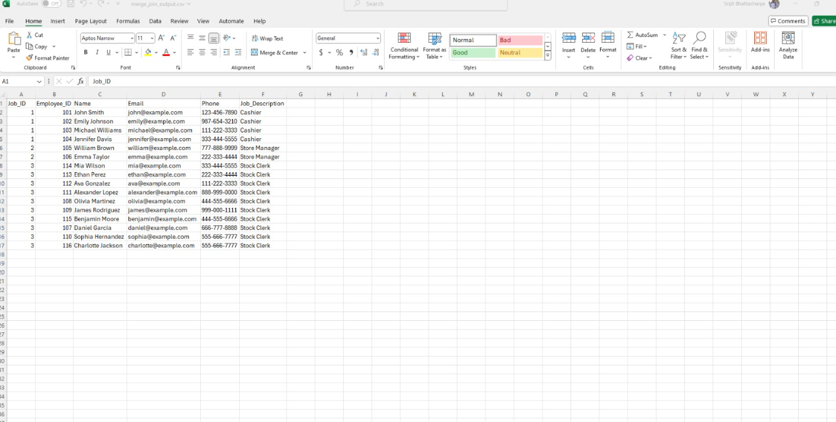

Data Visualization in Power BI

Loading data-

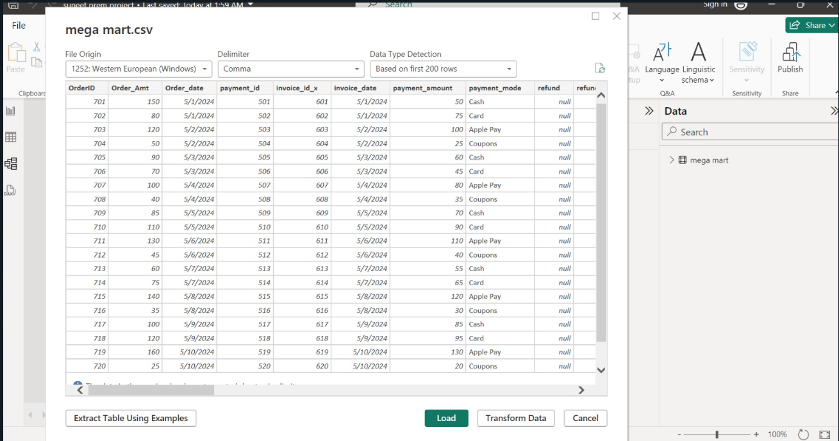

Data Visualization

Summary-

* Total payment according to products
* Payment_mode
* Product_category

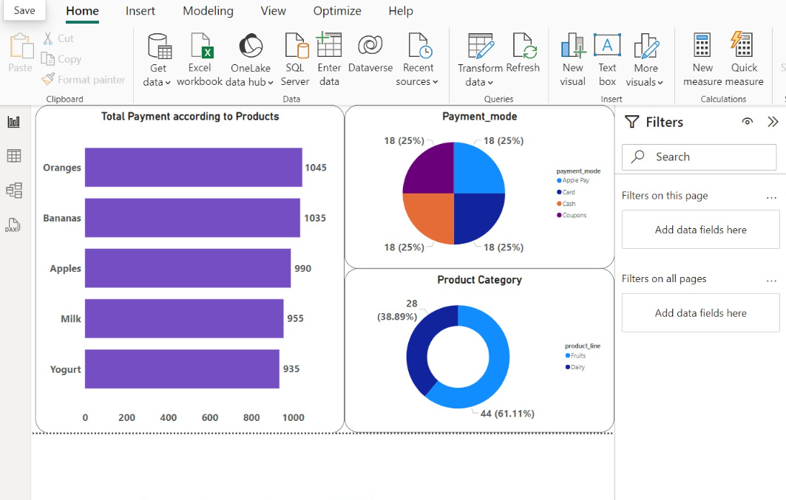

Employee enrolled in different jobs

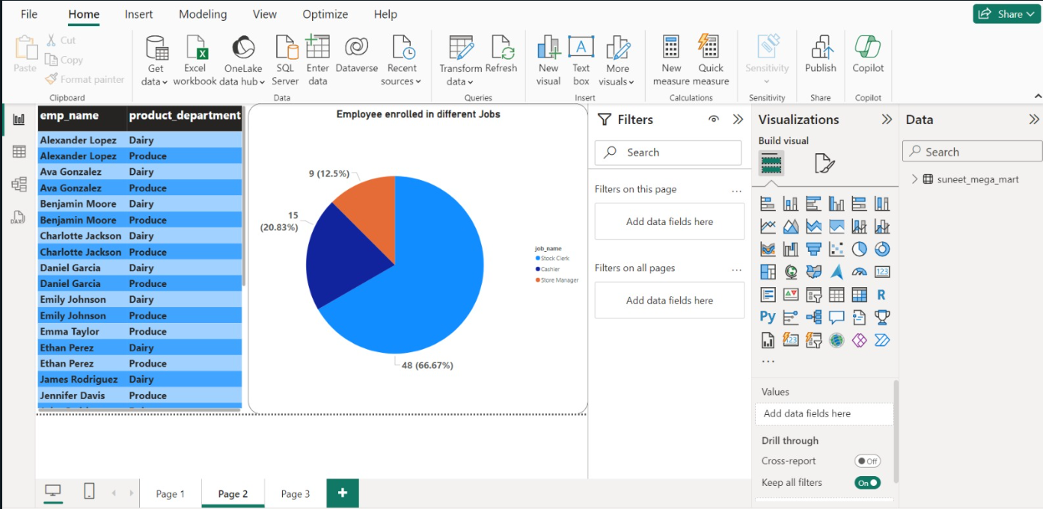

Vendors chart-

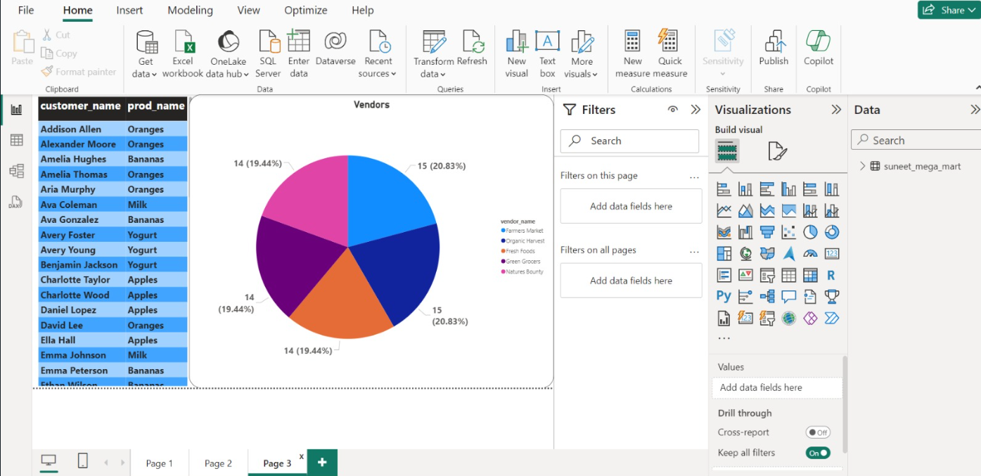

Sum of orders sorted by year, month and day.

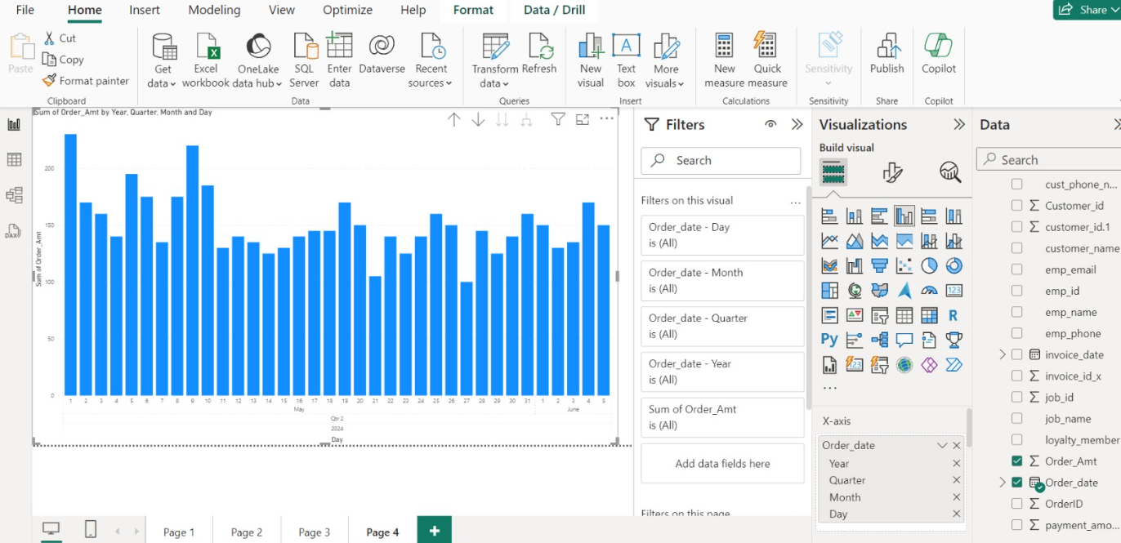

Conclusion:

* By exploring the data warehouse inventory, Mega Mart can identify products that are frequently sold out or are not selling well
* Information can be used to optimize inventory management and ensure that popular products are always in stock
* Can also be used to determine the ideal price points for different products based on their popularity and profitability.
* Can also be used to optimize the supply chain and reduce inefficiencies

Overall, exploring the inventory data warehouse of a grocery store can provide valuable insights that can be used to improve various aspects of the business, from inventory management to customer experience